**Hadoop Developer Training – Hive Lab Book**

**INPUT TABLES**

1. **Customer**

|  |  |  |  |
| --- | --- | --- | --- |
| **SNUM** | **SNAME** | **CITY** | **COMM** |
| 1001 | Peel | London | 0.12 |
| 1002 | Serres | San Jose | 0.13 |
| 1004 | Motik | London | 0.13 |
| 1007 | Rifkin | Barcelona | 0.15 |
| 1003 | Axelrod | New York | 0.1 |
| 1005 | Fran | London | 0.26 |

1. **SalesPeople**

|  |  |  |  |  |
| --- | --- | --- | --- | --- |
| **CNUM** | **CNAME** | **CITY** | **RATING** | **SNUM** |
| 2001 | Hoffman | London | 100 | 1001 |
| 2002 | Giovanni | Rome | 200 | 1003 |
| 2002 | Giovanni | Rome | 200 | 1003 |
| 2003 | Liu | San Jose | 200 | 1002 |
| 2004 | Grass | Berlin | 300 | 1002 |
| 2005 | Clemens | London | 100 | 1001 |
| 2006 | Cisneros | San Jose | 300 | 1007 |
| 2007 | Preira | Rome | 100 | 1004 |

1. **Order Detail**

|  |  |  |  |  |
| --- | --- | --- | --- | --- |
| **ONUM** | **AMT** | **ODATE** | **CNUM** | **SNUM** |
| 3001 | 18.5 | 10/3/1996 | 2008 | 1007 |
| 3002 | 707.5 | 10/3/1996 | 2001 | 1001 |
| 3003 | 1900.1 | 10/3/1996 | 2007 | 1004 |
| 3004 | 5160 | 10/3/1996 | 2003 | 1002 |
| 3005 | 1090 | 10/4/1996 | 2008 | 1007 |
| 3006 | 1780.5 | 10/4/1996 | 2002 | 1003 |
| 3007 | 75.5 | 10/5/1996 | 2002 | 1003 |
| 3009 | 1725.5 | 10/5/1996 | 2006 | 1003 |
| 3010 | 980.88 | 10/6/1996 | 2004 | 1002 |
| 3011 | 4560.5 | 10/6/1996 | 2006 | 1001 |

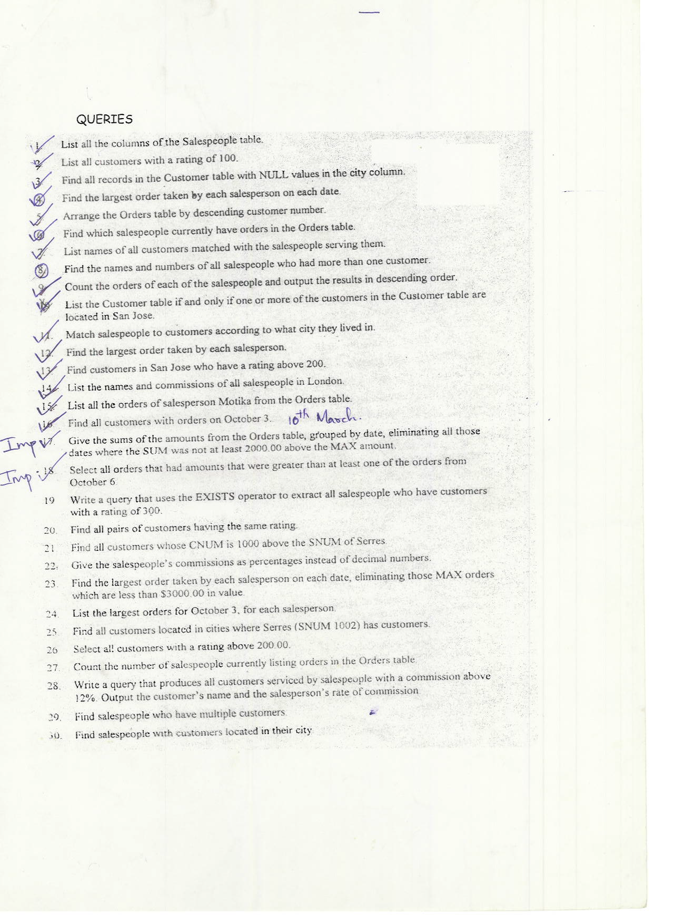

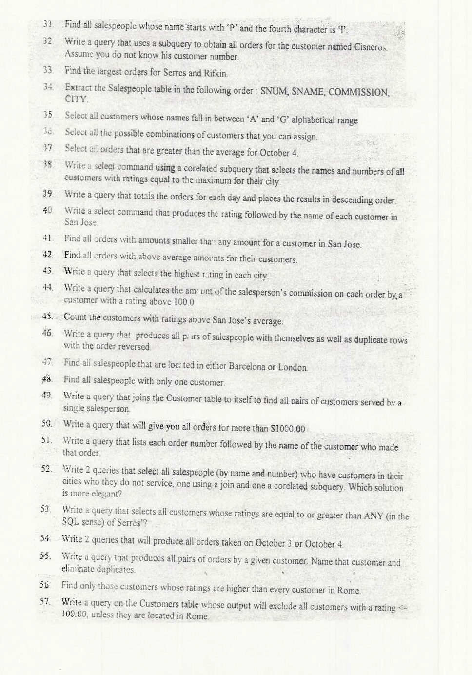

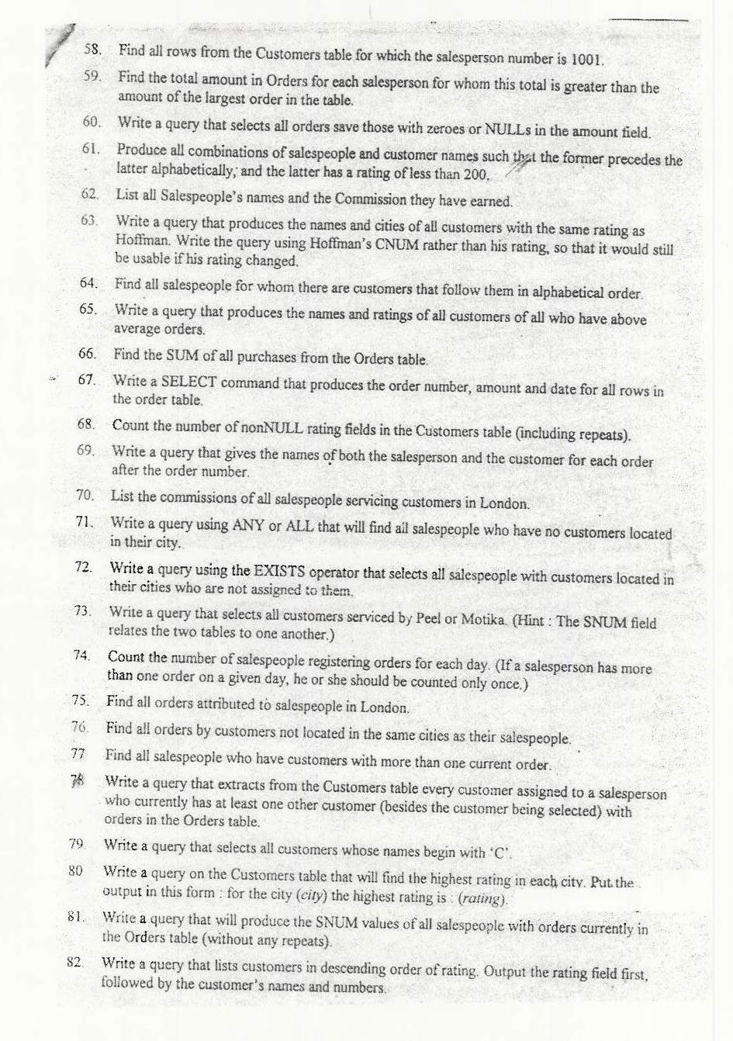



**Solutions**

**List all the columns of the salespeople table.**



**List all the customers with the rating of 100.**



**Find all the records in the customer table with NULL values in the city column**



**Find the largest order taken by each salesperson on each date.**

Select snum,odate,MAX(amt) from orders group by snum,odate;



**Arrange the orders table by descending customer number.**



**Find which salespeople have orders in the order table.**

Select distinct salespeople.sname from salespeople1 inner join orders on salespeople.snum = orders.snum;



**List names of Customers matched with salespeople serving them.**



**Find the names and numbers of all salespeople who had more than one customer.**



**Count the order of each of the salesperson and output the results in descending order.**

Select snum,COUNT(onum) from orders group by snum order by snum DESC;



**List the Customer table if and only if one or more of the customers in the customer table are located in San Jose.**



**Match Salespeople to customers according to what city they lived in.**



**Find the largest order taken by each salesperson.**



**Find customers in San Jose who have rating above 200.**

Select cname from customers where city = ‘San Jose’ and rating > 200;



**List the names and commission of salespeople in London**



**List all the orders of salesperson motika from orders table.**



**Find all the customers with orders on October 3rd**



**Give the sums of the amounts from the orders table grouped by date, eliminating all those dates where the sum was not at least 2000.00 above the max amount.**





**Select all the orders that had amounts that were greater than at least one of the orders from October 6.**





**Write a query that uses the exists operator to extract all the salespeople who have customers with the rating of 300.**



**Find all the pairs of customers having the same rating.**



**Find all the customers whose CNUM is 1000 above the SNUM of Serres.**





**Give the salespeople’s commissions as percentages instead of decimal numbers.**



**Find the largest order taken by each salesperson on each date, eliminating those MAX orders which are less than $3000.00 in value.**



**List the largest orders for October 3, for each salesperson.**



**Find all the customers located in cities where Serres (SNUM 1002) has customers.**





**Select all the customers with a rating above 200.**



**Count the number of salesperson currently listing orders in the orders tables.**

Select count(distinct salespeople.snum) from salespeople inner join orders on salespeople.snum = orders.snum;



**Write a query that produces all the customers serviced by salespeople with a commission above 12%. Output the customer’s names and the salespeople’s rate of commission.**



**Find the salespeople who have multiple customers.**



**Find salespeople with customers located in their city.**



**Find all the salespeople whose name starts with ‘P’ and the fourth character is ‘l’.**



**Write a query that uses a subquery to obtain all orders for the customers named Cisneros. Assume you do not know his customer number.**



**Find the largest order for Serres and Rifkin.**



**Extract the salespeople table in the following order: SNUM, SNAME, COMMISSION, and CITY.**



**Select all the customers whose names fall in between ‘A’ and ‘G’ alphabetical range.**

Select * from customers where cname between (‘A%’) and (‘G%’);



**Select all the possible combinations of customers that you can assign.**

Select distinct salespeople.sname,customers.cname from salespeople inner join customers1;



**Select all orders that are greater than the average for October 4.**





**Write a select command using the correlated subquery that selects the names and numbers of all customers with ratings equal to the maximum for their city.**



**Write a query that totals the orders for each day and places the results in descending order.**



**Write a select command that produces the rating followed by the name of each customer in San Jose.**



**Find all orders with amount smaller than any amount for a customer in San Jose.**

Select orders.amt,customers.cname from orders inner join customers on orders.cnum = customers.cnum where customers.city = ‘San Jose’;





**Find all the orders with above average amounts for their customers.**





**Write a query that selects the highest rating in each city.**



**Write a query that calculates the amount of the salespeople’s commission on each order by a customer with a rating above 100.0.**

Select salespeople.sname,salespeople.comm * orders.amt, customers.cname,customers.rating from salespeople inner join orders on salespeople.snum = orders.snum inner join customers on orders.cnum = customers.cnum where customers.rating > 100 group by salespeople.sname, salespeople.comm * orders.amt, customers.cname,customers.rating;



**Count the customers with rating above San Jose’s average.**





**Write a query that produces all pairs of salespeople with themselves as well as duplicate rows with the order reserved.**



**Find all the salespeople located in either Barcelona or London.**



**Find all the salespeople with only one customer.**



**Write a query that joins the customer table to itself to find all the pairs of customers served by single salespeople.**

**select a.snum,a.cname from customers1 a inner join customers1 b on a.snum = b.snum group by a.snum,a.cname,b.cname having count(a.snum) = 1 and a.cname != b.cname;**



**Write a query that will give you all orders for more than $1000.00.**



**Write a query that lists each order number followed by the name of the customers who made that order.**



**Write 2 queries that select all salespeople (by name and number) who have customers in their cities who they do not service. One using a join and one a correlated subquery. Which solution is more elegant?**



**Write a query that selects all customers whose ratings are equal to or greater than any (in the sql sense) of Serres?**





**Write 2 queries that will produce all orders taken on October 3 or October 4.**



**Write a query that produces all pairs of orders by a given customer. Name that customer and eliminate duplicates.**



**Find only those customers whose ratings are higher than every customer in Rome.**





**Write a query on the customers table whose output will exclude all the customers with a rating 100.00 unless they are located in Rome.**



**Find all rows from the customers table for which the salesperson’s number is 1001.**



**Find the total amount in orders for each salesperson for whom this total is greater than the amount of the largest order in the table.**





**Writ e a query that selects all orders save those with zeros or null’s in the amount field.**



**Produce all combinations of salespeople and customer names such that the former precedes the latter alphabetically and the latter has a rating of less than 200.**



**List all salespeople’s name and commission they have earned.**



**Write a query that produces the names and cities of all customers with the same rating as Hoffman. Write the query suing Hoffman’s cnum rather that his rating so that it would still be usable if his rating changed.**







**Find all salespeople for whom there are customers that follow them in alphabetical order.**



**Write a query that produces the names and rating of all customers of all who have above average orders.**





**Find the SUM of all purchases from the Orders table.**



**Write a select command that produces the order number, amount and date for all rows in the order table.**



**Count the number of non NULL rating fields in the customers table.**



**Write a query that gives the names of both the salesperson and the customer for each order after the order number.**



**List the commissions of all salespeople servicing customers in London.**



**Write a query using any or all that will find all salespeople with no customers located in their city.**



**Write a query using exists operator that selects all salespeople with customers located in their cities who are not assigned to them.**



**Write a query that selects all customers serviced by peel or motika.**



**Count the number of salespeople registering order for each day.**



**Find all orders attributed to salesperson in London.**



**Find all orders by customers not located in the same cities as their salespeople.**



**Find all salespeople who have customers with more than one current order.**



**Write a query that extract from the customers table every customer assigned to a salesperson who currently has at least one other customer with orders in the orders table.**



**Write a query that selects all customers whose names begin with ‘C’.**



**Write a query on the customers table that will find the highest rating in each city. Put the output in this form: for the city (city) the highest rating is : (rating)**



**Write a query that will produce the SNUM values of all salespeople with orders currently in the Orders table (no repeats).**



**Write a query that lists customers in descending order of rating. Output the rating field first, followed by the customer’s names and numbers.**



**Find the average commission for salespeople in London.**



**Find all orders credited to the same salespeople who have given service to Hoffman (cnum 2001).**





**Find all salespeople whose commission is between 10 and 12(both inclusive)**



**Write a query that selects each customer’s smallest order.**



**Write a query that counts the number of non null city values in the customer table.**



**Find all customers who are not located in San Jose and whose rating is above 200.**



**Which salespeople attend to customers not in the city that have been assigned to them?**



**Which salespeople get commission greater than 11 and are serving customers rated less than 250.**



**Write a query to get the details of the customer who has given the maximum number of orders.**

**On which days has Hoffman placed orders?**





**How many salespeople have succeeded in getting orders?**



**How many customers have placed orders?**



**On which date has each salesperson booked an order of maximum value.**



**Who is the most successful salesperson?**



**Who is the worst customer with respect to the company?**



**Find all orders greater than the average for October 4th.**





**Which customers have above average orders.**





**List all customers with ratings above San Jose’s average.**





**Select the total amount in orders for each salesperson for whom the total is greater than the amount of the largest order in the table.**





**Give names and numbers of all salespersons who have more than one customer.**



**Select all salespersons by name and number who have customers in their city whom they don’t service.**



**Which salesperson(s) should be fired?**



**Calculate the commission for each salesman.**

Select sname,SUM(comm.*amt) from salespeople1 inner join orders1 on salespeople.snum = orders.snum group by sname;

